**DEPARTMENT OF**

**ELECTRONICS AND COMMUNICATION ENGINEERING**

**College of Engineering and Technology**

**SRM Institute of Science and Technology**

MINI PROJECT REPORT

EVEN Semester, 2021-22

Lab code & Name : 18ECC201J- Analog Electronic Circuits

Year & Semester : II Year, IV semester

Project Title : **TOUCH SWITCH USING TRANSISTOR**

Course Teacher **: Dr. J. Manjula**

Associate Professor

Electronics and Communication Department

Team Members : KUNAL KESHAN (RA2011004010051)

GANNI LIKHIT (RA2011004010048)

MUKTHAPURAM SIVARAM CHANDRAN (RA2011004010049)

| Reg. No | RA2011004010048 | RA2011004010049 | RA2011004010051 |
| --- | --- | --- | --- |
| Mark split up |
| Novelty in the project work  (2 marks) |  |  |  |
| Level of understanding of the design formula (4 marks) |  |  |  |
| Contribution to the project  (2 Marks) |  |  |  |
| Report writing (2 Marks) |  |  |  |
| **Total (10 Marks)** |  |  |  |

Date: **Signature of Course Teacher**

**TOUCH SWITCH USING TRANSISTOR**

**OBJECTIVE:**

To build a touch switch circuit using BC547 Transistors to demonstrate the flow of electricity upon contact of a conductive object (skin) on the touch component of the circuit.

**ABSTRACT:**

The touch switch circuit using BC547 upon contact of the touch component facilitates the flow of current to the load upon contact, and when there’s no contact it works as an off switch.

The main application of this circuit is involved in touch screens, where an array of this component are used to detect touch to turn on display. It’s also used in musical instruments like electric drums.

**INTRODUCTION:**

The touch switch circut uses BC547 transistors, and metal strips connected at the base and collector of one trasistor, which when touched with a conductive material produces the biasing of the transistor allowing current to flow through it.

**HARDWARE REQUIREMENT/DESCRIPTION:**

BC547 NPN Transistor, Resistors - 100k ohms and 270 ohms, Metal Strips, LED, 9v battery, Bread board and connecting wires.

**CIRCUIT/COMPONENT SPECIFICATIONS:**

| Supply voltage (*V*CC) | 6 to 9 V |
| --- | --- |
| Supply current (*V*CC = +5 V) | 4 to 6 mA |
| [Operating temperature](http://en.wikipedia.org/wiki/Operating_temperature) | -65 to 150 °C |

**CIRCUIT DIAGRAM:**

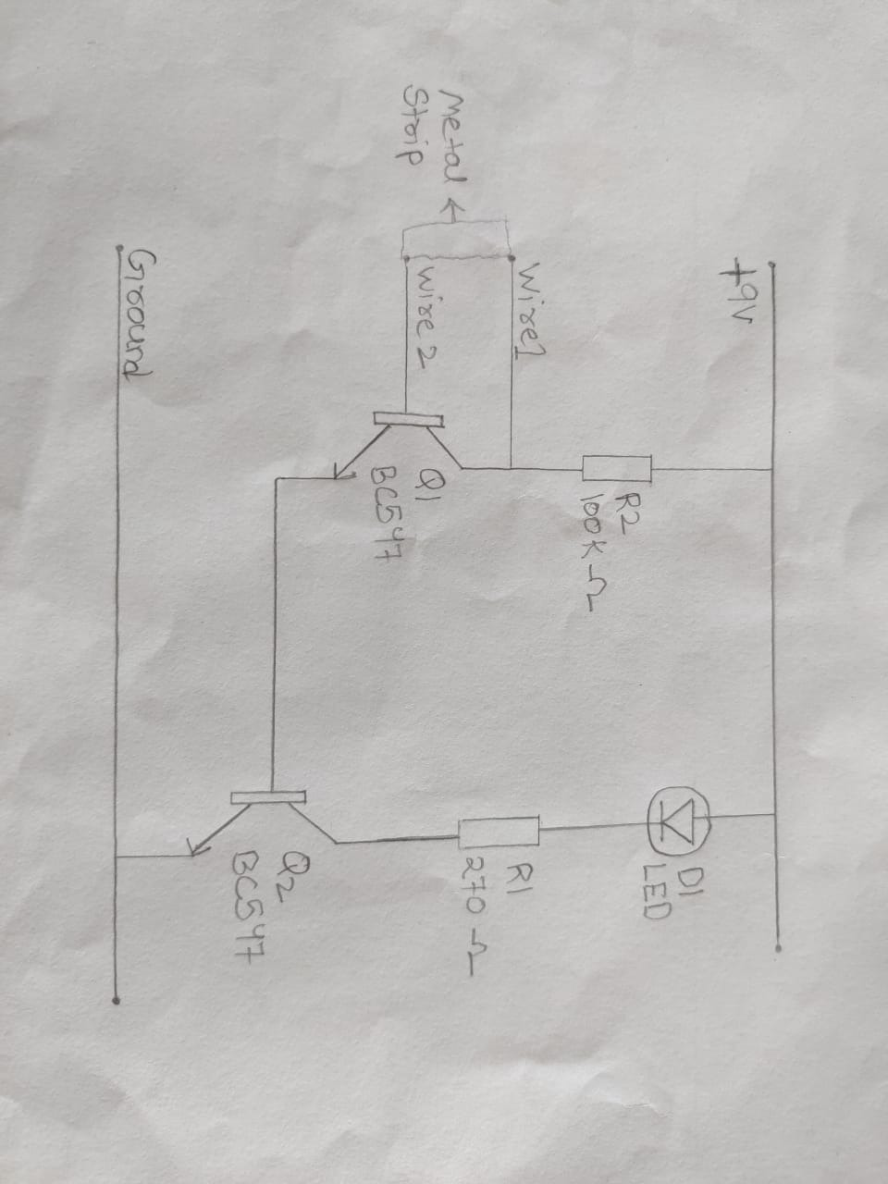

**DESIGN ISSUES:**

In this simple circuit, a single transistor can be used as well, but it will not produce enough current to switch the LED on. Hence, two transistors are used inorder to amplify the current and facilitate the on and off action.

When used in larger applications like in a touchscreen device, an array of these components should be used with the appropriate biasing and power supply to show the switching action.

**APPROACH/METHODOLOGY:**

For current applications, the flow of current requires conductive material to faciliate the flow of electrons. In such a circuit, we can use the touch application to provide biasing to a transistor to act as a switch when it is touched by a conductive material.

**CONCLUSIONS:**

The Touch switch circuit was constructed and functions as a on/off switch upon contact.

**REFERENCES:**

https://circuits-diy.com/how-to-make-simple-touch-switch-circuit-using-transistor-basic-electronics/

**APPENDIX:**

**BC547 NPN Transistor**

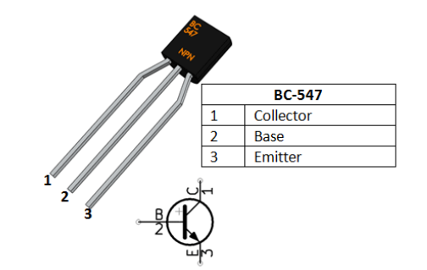

BC547 is a NPN transistor hence the collector and emitter will be left open (Reverse biased) when the base pin is held at ground and will be closed (Forward biased) when a signal is provided to base pin.

**Resistors**

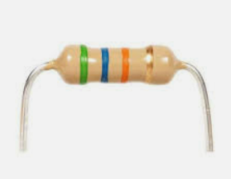

Used to bias the transistors in the right biasing conditions in order to get amplification.

**Metal Strips**

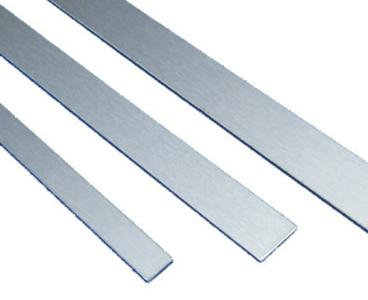

Touch component of the circut where upon contact, the electricity will flow. I.e. Help bias the transistors when there is contact.

**LED**

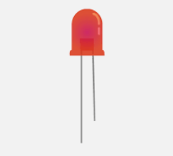

Used to indicate the flow of the electricity after touch switch is on.

**9v Battery**

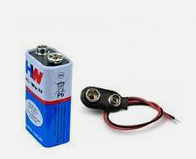

Power supply to the components.

**Bread Board and Connecting Wires**

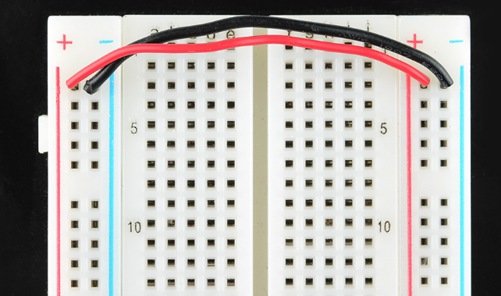

Used for assembly of circuit.

**TOUCH SWITCH USING TRANSISTOR**

KUNAL KESHAN – RA2011004010051

GANNI LIKHIT – RA2011004010048

MUKTHAPURAM SIVARAM CHANDRAN – RA2011004010049

| OFF State | ON State |
| --- | --- |
|  |  |